Task 3.2: Storing Data with Web Storage
Overview
In this Touchstone task, you will store and retrieve data using web storage. Specifically, you will do the following:
- Use sessionStorage to add items to the shopping cart as a part of the implementation of the “Add to Cart” feature on the Gallery webpage.
- Retrieve information about the added items in the shopping cart using sessionStorage as a part of the implementation of the “View Cart” feature on the Gallery webpage.
- Clear items from the sessionStorage as a part of the “Clear Cart” and/or “Process Order” features.
- Add customer feedback/custom order information to the localStorage from the web form in the About Us/Contact webpage.

Document any issues or errors you encounter in your code development that prevent your stylesheet or webpages from functioning as intended.

Remember, the component colors, font colors, and typography styling should be consistent with your choices in Task 1 and should be appropriate according to the client description provided in the Client Scenario and Criteria.

Instructions
Provide your responses in the following table.

Shopping Cart Items Screenshot
Hint: Provide the screenshot for the shopping cart window displaying the item information.

- The “View Cart” modal window should display the item information by reading from the sessionStorage.

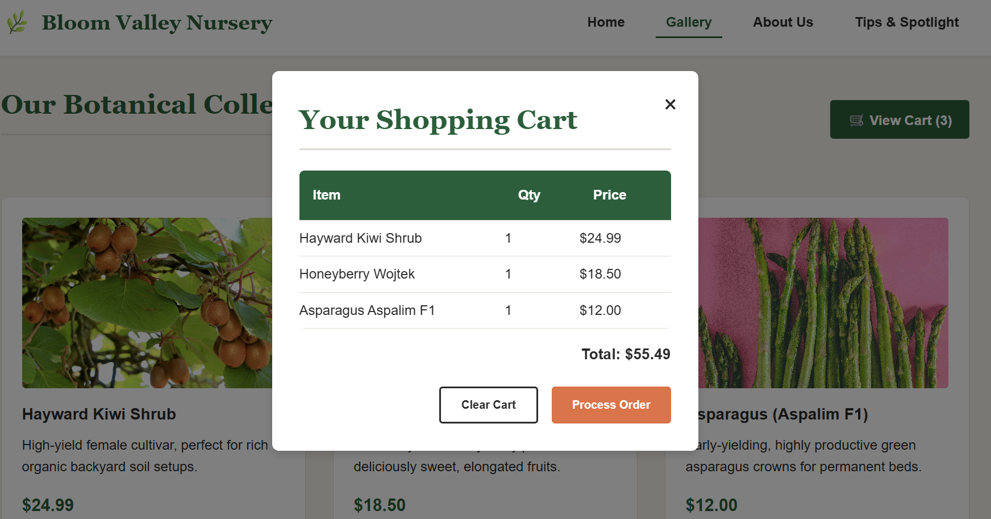

Shopping Cart Empty Screenshot
Hint: Provide the screenshot for the shopping cart window when the cart is cleared using the “Clear Cart”/“Process Order” button.

- The “Clear Cart”/“Process Order” button in the modal window should clear all the item information in the sessionStorage.

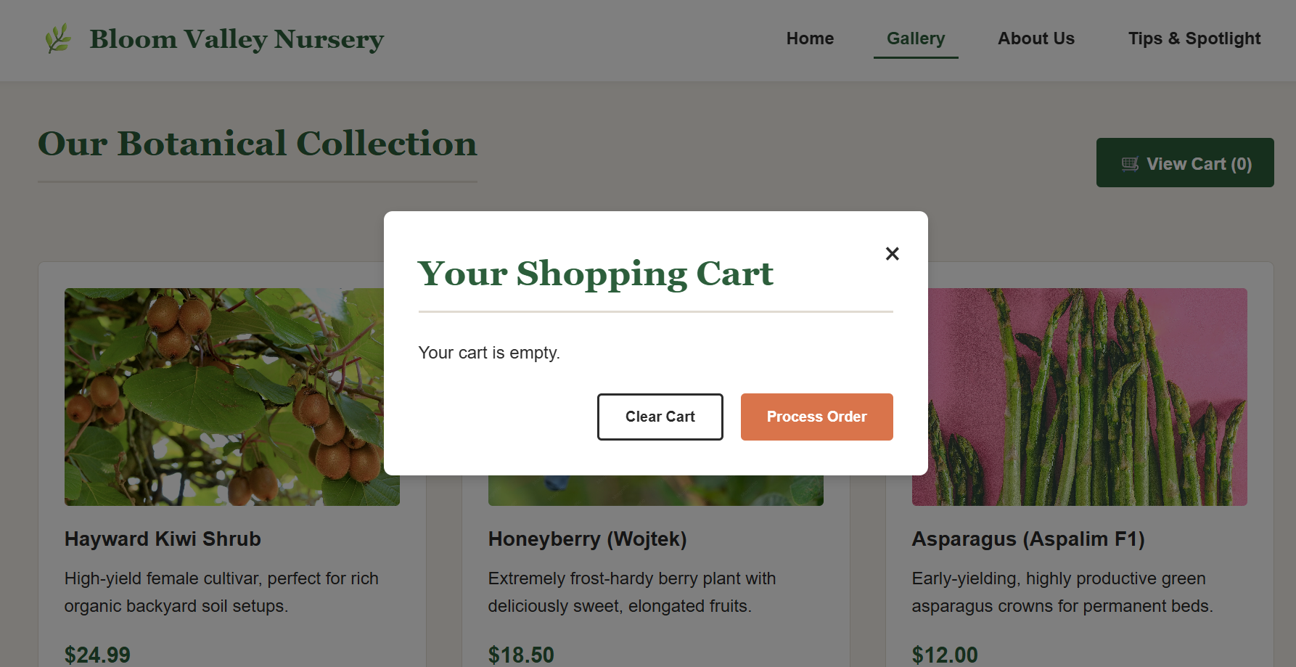

Browser SessionStorage Screenshot (Before Clearing Items)
Hint: Provide the screenshot of the browser sessionStorage after adding the items and before clearing the items. Use “Ctrl” + “Shift” + J to open the browser console window in the Google Chrome browser, click the “>>” button, and select “Application.” Then, find the sessionStorage under the Storage category.

- The sessionStorage should show all the items currently added to the shopping cart.


Browser SessionStorage Screenshot (After Clearing Items)
Hint: Provide the screenshot of the browser sessionStorage after clearing the items. Use “Ctrl” + “Shift” + J to open the browser console window in the Google Chrome browser, click the “>>” button, and select “Application.” Then, find the sessionStorage under the Storage category.

- The sessionStorage should be empty as all the items are removed from the sessionStorage.
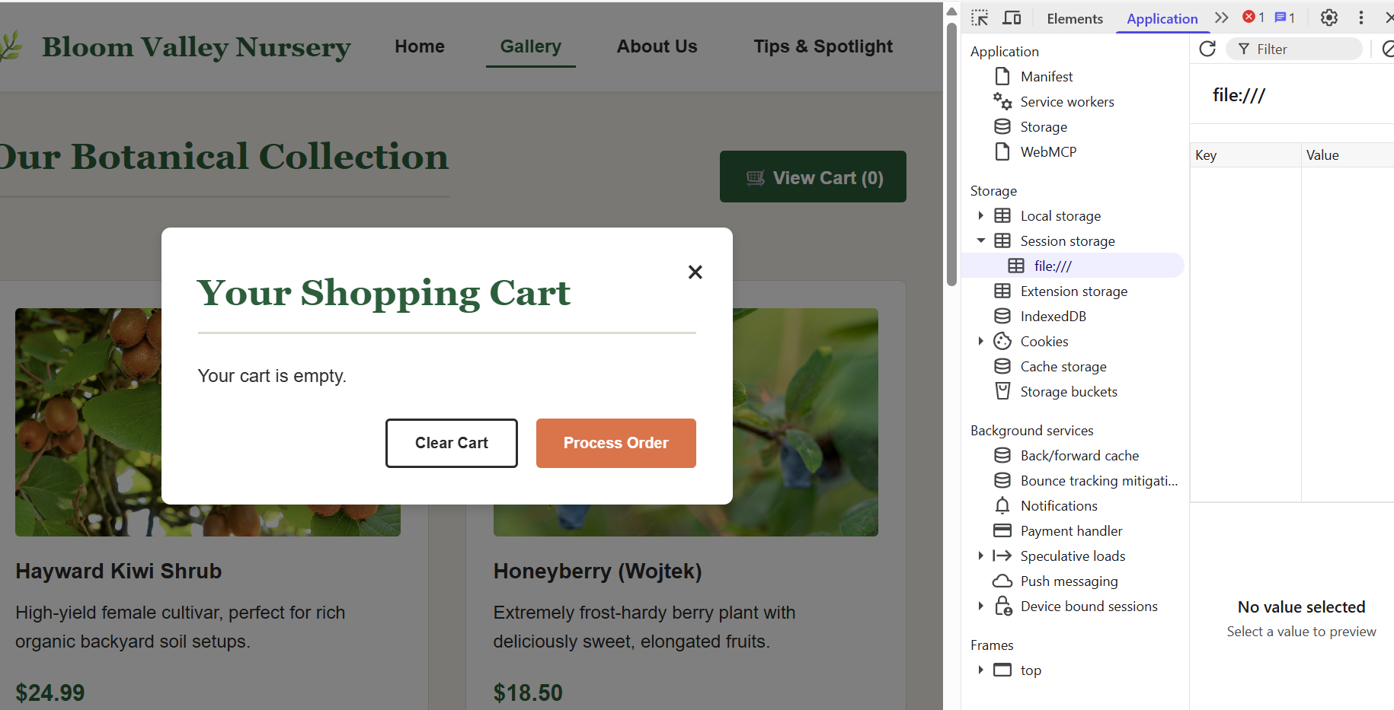

Shopping Cart Analysis
Hint: Provide a brief description of how the web storage was utilized in implementing the shopping cart.
I utilized the web storage API to seamlessly persist and manage shopping cart data across the application. When a user interacts with an item on the Gallery page, the script reads metadata attributes (data-id, data-name, data-price) from the button element and appends them to a structured JavaScript array. This array is immediately serialized using JSON.stringify() and saved into storage under the nursery_cart key. When opening the dynamic modal view, the system uses JSON.parse() to retrieve and deserialize this data, dynamically building the HTML table elements to render the items and total price accurately. Clicking "Clear Cart" or processing an order destroys the storage reference to clear the system state.

Custom Order Screenshot
Hint: Provide the screenshot displaying the About/Us webpage.

- Add custom order information to the localStorage from the web form in the About Us/Contact webpage.
- The custom order web form should save the customer information and feedback/custom order information in the localStorage.

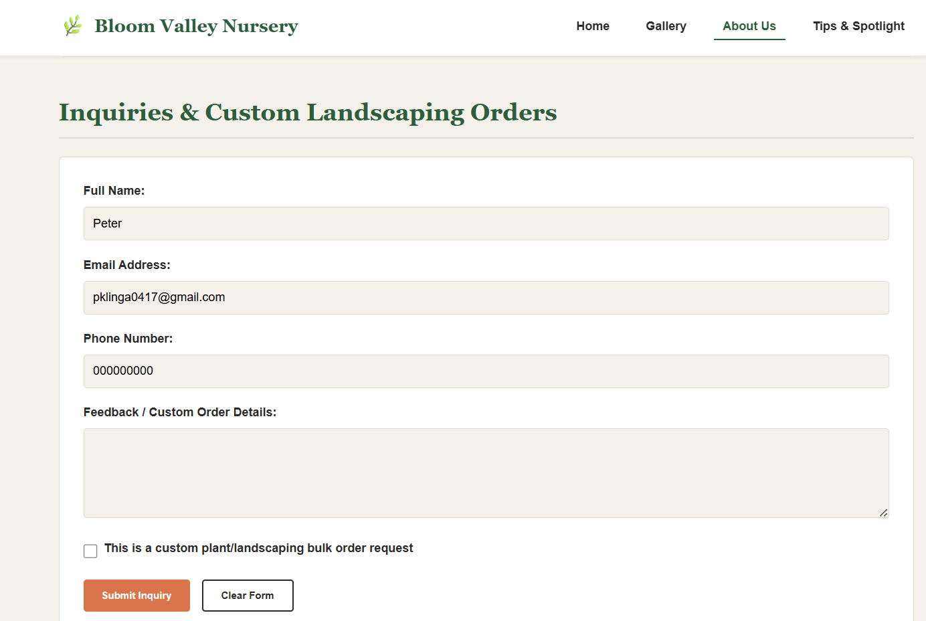

Browser localStorage Screenshot (After Submitting Form)
Hint: Provide the screenshot of the browser localStorage after submitting the form in the About Us/Contact page. Use “Ctrl” + “Shift” + J to open the browser console window in the Google Chrome browser, click the “>>” button, and select “Application.” Then, find the localStorage under the Storage category.

- The localStorage should display the customer information and the feedback/custom order information.
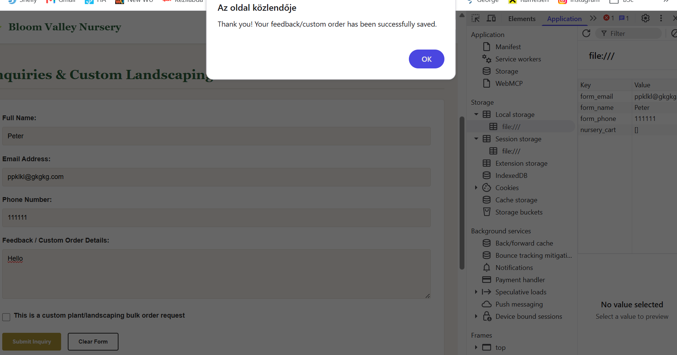

Custom Order Information Analysis
Hint: Provide a brief description of how the web storage was utilized in storing the custom order information.

I utilized both localStorage and sessionStorage APIs within the contact form module to balance user identification with transient session state security. For structural persistent profile properties—including the client's name, email, and telephone parameters—the script binds event listeners that commit data straight to localStorage on every keystroke (input events).
Conversely, context-specific custom request data, such as the text inside the message canvas and the Boolean evaluation state of the custom order checkbox (#custom-order-flag), are written instantly to sessionStorage arrays. When the page paints or refreshes, the application immediately executes conditional lookups to re-populate the input containers from these separate backends. This hybrid approach guarantees data preservation across navigating individual tabs while isolating custom order payloads to a single operational window.

Testing and Error Reporting
Hint: While writing and testing your code, record any errors, and state your approach to fixing the errors. Did the outcome look the way you expected? Did you find anything particularly difficult to accomplish?
I have already described these in the previous Tasks
I have already described these in the previous Tasks

